Cache and Query
Result Cache – a new Silver Bullet?

Jaromír D.B. Němec,
DB-Nemec.com
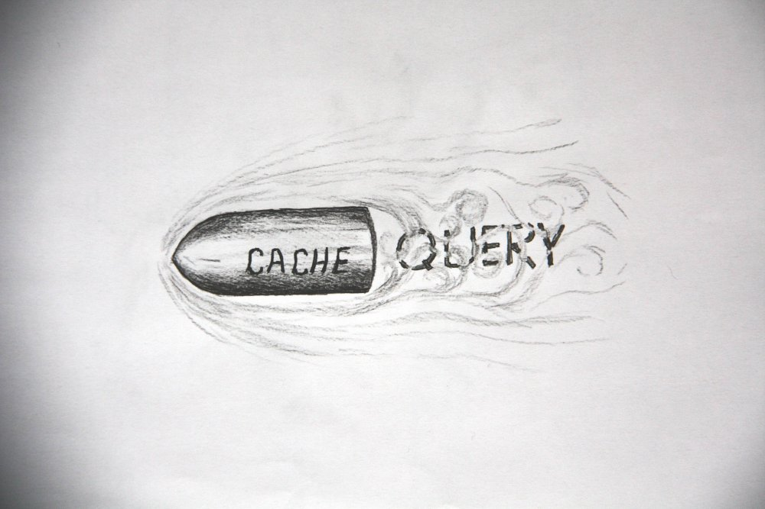 © Pepa Nemec
Introduction

This paper is an accompanying paper to a presentation and is based therefore on a story. The story takes us to the large company “PowerOfTwo”, currently fighting with performance problems in the database. A junior DBA proposed to use the new feature of server result caching as a remedy. We will investigate the use cases where the result cache is useful and will introduce monitoring measures of the cache efficiency.
In the mean time the senior DBA was engaged and proposed to use a materialized view to address the problem. This approach works fine only to leave us with a next problem of scheduling the refreshing of the materialized view – neither using 'on commit' nor periodical refresh are suitable.
To solve the dilemma we use the internal mechanism of result caching – the Database Change Notification mechanism. This feature was introduced to control the cache invalidation in case of any change of the source objects of the cached queries.
The deployment of the Database Change Notification to perform a refresh of the materialized view is the final piece of the solution of the performance problem.

Result Cache

The Brief History of Cache in the Database
The Oracle database has traditionally strong support for caching - think of a buffer pool, a library cache or object statistics.
All those caches at least up to Oracle 10g - are located on the lower levels of DB architecture, not on the interface level.
Why is this?
IMO the simple reason is that DB designers think rationally and don't expect
much profit from a cache on a user interface.

The Cache Dilemma
A small data source defines a limited set of queries on it, which can be effectively cached. Bingo! But wait, the effect of such a cache will be limited as the queries are expected to be very effective themselves due to the small data source.
On large data sources only a small part of the queries can be covered with
the cache. So paradoxically the cache will shine only if the application will repeatedly ask for the same data again and again. One could ask why the application needs repeatedly the same data but this is another question.

I mentioned the rationality in the database design shortly. Lets have a look on the result cache from the application part of the fence. As an application I understand Java Application Servers, Spring, Hibernate and such stuff. The cache concept on the statement (i.e. interface) level can be found everywhere. Hibernate – an often used DB access tool - for example supports two levels of the cache. The second level even allows to exchange the caching provider.
Why is caching in applications more penetrated? Lets assume the application designers are more realistic (or pragmatic or pessimistic as you like); they expect and plan for the case of repeating access of the same data.

Finally after even MySQL has the feature of a result cache, the Oracle database must follow – so the result cache was introduced in the 11g version.
Note that additionally to the server result cache there is a feature of a client result cache – this feature is not considered in this paper.

The Problematic Query

This introduction is apparently rather a non standard presentation of the result cache feature. A classical presentation shows a query taking half a minute (a maximum that the audience can hold) and repeats the query resulting in an instant response.
So let's quickly do it.
We will use a privilege table of a fictional PowerOf2 company for our demonstration. The company is hierarchically organized and each person holds their own privileges and all privileges of their dependent persons. To get a complete overview of the privileges, a hierarchical query of the whole sub tree must be performed.

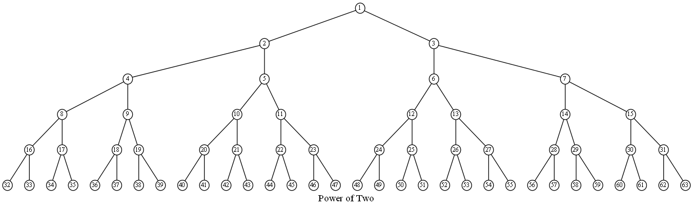

Figure1 The structure of the Power of Two company

A sample query of the data is show below:

-- Query A
select /*+ RESULT_CACHE */ id, boss_id, encode_privs(priv, .005) privs
from priv_table a
start with id = 512
connect by prior id = boss_id
;

Query A runs slowly; it returns 500 rows in approximately 15 seconds. But we used the RESULT_CACHE hint, so lets repeat the query.
The second run is as slow as the previous one, so what’s the problem here?
Any ideas?

The clue is the number of returned rows – 500 in our case. This is exactly the fetch size defined in SQL Developer. If we page down to the last row, we get 512 rows. The third run of the query is instant. This leads us to a following lesson:

Rule 1: Only full fetched result sets can be cached

This comes not really as a surprise. There is a strong logical explanation of the behaviour. How could the cache provide a full data set next time if the previous query delivered only a part of it?

Lets demonstrate the query A once more from SQL*Plus.
@queryA

We will try to find the answer of the following questions:
How can we identify that the query was processed with the result cache?
How can we identify that the query was resolved from the result cache?

The indication of the processing of the statement in the result cache is the RESULT CACHE operation in the explain plan.

---------------------------------------------------------------------
| Id | Operation | Name |
---------------------------------------------------------------------
| 0 | SELECT STATEMENT | |
| 1 | RESULT CACHE | ft6a1dvfrywds39660p36gu9k4 |

The best indication of the returning of the query from a result cache is the low elapsed time (near zero) and the zero number of consistent gets.

Note that to demonstrate the functionality we used the FLUSH procedure from the DBMS_RESULT_CACHE package.

Let's drive our attention to a second query (same query as before but only with a different “starting point”).

-- Query B
select /*+ RESULT_CACHE */ a.*
from priv_table a
start with id = 1
connect by prior id = boss_id
;

This is the master query for all privileges of the boss with id = 1, so we expect a larger result set as in the previous query.

@queryB

The query yields more that 260K records in about 6 seconds.

A repeated run of the queryB triggers no caching effect – even if we apparently fetched all rows as required by the rule above. What’s the problem now?
The key to the answer provides the fixed views v$result_cache_statistics and v$result_cache_objects.

SQL> select name, value from v$result_cache_statistics order by id;

NAME VALUE
----------------------------------- --------------------
Block Size (Bytes) 1024
Block Count Maximum 1024
Block Count Current 0

Result Size Maximum (Blocks) 921
Create Count Success 0
Create Count Failure 0
Find Count 0
Invalidation Count 0
Delete Count Invalid 0
Delete Count Valid 0
Hash Chain Length 0

11 rows selected.

The most important information in the v$result_cache_statistics view is the limitation of the result set size (property Result Size Maximum (Blocks)). This property is configured as a percentage of the total cache size in block using the parameter result_cache_max_result.

Checking the second fixed view after the run of the query we see:

SQL> select status, name, block_count from
2 v$result_cache_objects
3 where type = 'Result';

STATUS NAME BLOCK_COUNT
--------- ----------------------------------- -----------
Invalid select /*+ RESULT_CACHE */ a.* 921
from priv_table a
start with id = 1
connect by prior id = boss_id

We can deduce that the result set of the query has a larger size than allowed. After depleting 921 blocks of cache, the processing was interrupted (status = invalid) and the query is not cached and can’t be reused in the next run.

This leads us to the second rule:

Rule 2: The size of the result set to be cached is limited by the parameter result_cache_max_result

Cache Hit Ratio

How to measure the overall result cache efficiency?
The important measures are:

Create Count Success
Create Count Failure
Find Count
The fixed view v$result_cache_statistics provides useful again.
The meaning of those measures is illustrated in the status diagram below.

find
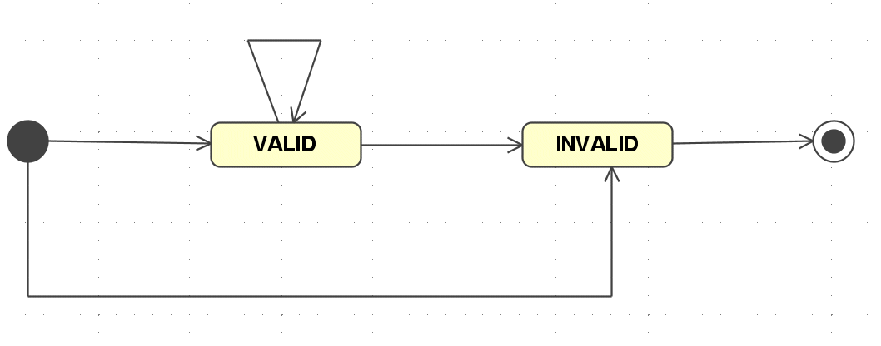
create
invalidate
delete

create failure

But what is the point of introducing a ratio in Oracle? Is it not a hopelessly obsolete concept?
A little explanation – a ratio was a very popular concept in Oracle at a given time, but fell in disgrace after the introduction of more rigorous measures. Does it mean that the Cache Hit Ratio (CHR) is meaningless as well? The important difference is that the result cache is defined on the user interface (and not at an internal level such as logical and physical reads). Therefore, the CHR is a meaningful measure.

The Find Count defines the number of the executions successfully resolved by the caching mechanism; the sum of all three measures is the total number of the execution. This leads us to the following formula for Cache Hit Ratio:

CacheHitRatio = Queries returned from the Cache / Total Number of Queries

The same formula using the measures from the v$result_cache_statistics view is as follows:

CHR =
Find Count / (Create Count Success + Create Count Failure + Find Count)

A second value is a Cache Allocation Percentage (ALLOC) – defined as the ratio of the blocks allocated in the cache with valid result sets to the maximum available size of the cache.

CacheAllocationPercentage = blocks allocated in the cache with valid result sets / maximum available size of the cache

The allocated blocks are queried from the v$result_cache_memory view using the FREE flag:

Alloc =
(select count(*) UsedBlocks from v$result_cache_memory where free = 'NO') / Block Count Maximum

The maximum result cache size is controlled by the parameter result_cache_max_size.

Cache Efficiency Monitoring

To demonstrate the cache measures live, we use a simple script that selects the fixed views once per second and calculates the results showing them on the screen (a sort of specialized snapper from Tanel Poder).
To simulate a load we will use our sample query. We start with a sort of dummy application that repeats the query again and again with the same value of the bind variable. We will scale towards a more realistic case using larger and larger numbers of different bind variables. The pattern can be shown as follows:

Start with … 1,1,1,1,…
1,2,1,2,1,2,…
1,2,3,1,2,3,1,2,3,…
Scale to …

The result of a sample run is shown below

% CHR % Alloc Crea cnt Find cnt Invd cnt Del cnt
99 70 1 121 0 0
99 73 1 171 0 0
98 76 2 180 0 0
99 82 1 192 0 0
99 85 1 164 0 0
99 87 1 121 0 0
99 90 1 123 0 0
99 93 1 160 0 0
99 93 1 155 0 0
100 96 0 147 0 0
% CHR % Alloc Crea cnt Find cnt Invd cnt Del cnt
99 99 1 119 0 0
96 99 3 79 0 2
0 99 4 0 0 4
0 99 3 0 0 3
0 99 4 0 0 4
0 99 3 0 0 3
0 99 4 0 0 4
0 99 4 0 0 4
0 99 3 0 0 3
0 99 4 0 0 4

The above part shows the lucky side of the run. The number of different queries (i.e. used BV values) is small, the cache is large enough to cover them all. This yields an excellent cache hit ratio and results in an execution of more than a 100 queries per second (see Find Cnt). After reaching the critical mass of the cache size everything changes dramatically. The cache is depleted (allocation is near 100%) and each creation triggers a deletion from the cache, which (due to our selected usage pattern) disables any cache reuse. The throughput drops to less than 5 queries per second.

Cache Invalidation
One important aspect of caching was left beside until now.
What happens if the base table is modified? Lets rerun our example and update the base table within the run.

Cache Size (Blocks) 1024 Result Size Maximum (Blocks) 102
% CHR % Alloc Crea cnt Find cnt Invd cnt Del cnt
100 31 0 388 0 0
100 31 0 344 0 0
99 34 1 394 0 0
95 34 12 243 12 12
100 34 0 365 0 0
100 34 0 304 0 0
99 36 1 348 0 0
100 36 0 363 0 0
100 36 0 354 0 0
99 39 1 419 0 0

After the update of the table, the invalidation count rises up (see bold line above). All cached queries become invalidated. This leads to a drop of the find count and the hit ratio. Only after a while – due to new creations – the hit ration rises again.
This is an important concept of the cache invalidation based on the feature Database Change Notification – we will use it in a short while.

Let’s recapitulate our experience thus far. If the privilege table is reasonably small (or the access pattern is limited) we can use result caching. Otherwise with a large table and a scattered access pattern, the result caching will be limited by the available cache size.
What can be a next step to increase the performance for our query?
Let's try to cover the hierarchical query with a materialized view.

Cache Usage Summary

Let's quickly recapitulate our experience so far.

Only some queries are suitable for caching – it is advisable to use explicit hints to enable result caching.

Cache parameters should be adjusted based on the monitoring of cache measures.

Result cache works efficiently especially for applications repeatedly accessing the same data..

Materialized View for Hierarchical Queries

Unfortunately Oracle doesn’t provide a direct (transparent) way for materialized views for hierarchical queries. This must be worked around with rewriting the original query. In a nutshell, the materialized view will pre-calculate the results for all possible values of the bind variables. A new column will be defined, the param_id. While querying the MV, we need not to use the connect by predicate but we simply access the MV with the predicate param_id = :id.
This construction replaces the potentially large number of index range scans only with one (larger) index range scan.

This approach is illustrated in the table below.

Original data
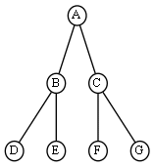
 | ID | BOSS_ID
 | 1 | NULL
 | 2 | 1
 | 3 | 1
 | 4 | 2
 | 5 | 2
 | 6 | 3
 | 7 | 3

Data in materialized view

PARAM_ID | ID | BOSS_ID  MV Parameter  A B C D . . . . . . .
1 | 1
1 | 2 | 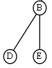  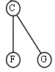  1  . . .
1 | 3 | 1
1 | 4 | 2
1 | 5 | 2
1 | 6 | 3
1 | 7 | 3
2 | 2 | 1
2 | 4 | 2
2 | 5 | 2
3 | 3 | 1
3 | 6 | 3
3 | 7 | 3
4 | 4 | 2
5 | 5 | 2
6 | 6 | 3
7 | 7 | 3

The definition of the MV is as follows.

create materialized view mv_priv_table
build immediate
refresh complete on demand
as
select
id, boss_id, priv,
to_number(substr(path,2,instr(path,',',1,2)-2)) param_id, path, my_level
from (
select sys_connect_by_path(id,',')||',' path, a.*, level my_level from priv_table a
connect by prior id = boss_id
start with id is not null
)
;

A sample query to get all privileges for the id = 1024 is shown below:

select id, boss_id, priv privs
from mv_priv_table a
where param_id = 1024
;

This query performs well, so are we done?
Ok, if the privilege table is mostly static, we are done. The MV is a sufficient solution.
If the data is dynamic, then we have two possibilities. Either periodically refresh the MV - say once per hour – or fast refresh the MV on commit. Frankly said, both solutions are sub optimal. The periodical refresh is not easy to schedule – what about a change once per month but we don’t tolerate more than a minute of stale data?
The on commit refresh can be highly invasive especially for complete refresh.

Fortunately, Oracle opens the cache invalidation interface and we can re-use it for our purpose.
Here comes the key idea of this presentation in play – we will use the same mechanism as used for the cache invalidation (Database Change Notification – see [1] for full details) as a trigger for the refresh of the MV.

Quick outline of the proposal:
- We define a change notification callback procedure and register it to be activated on the invalidation of the source table.
- The callback procedure will trigger the refresh of the MV.

Database Change Notification

The first step is the definition of the callback procedure.

CREATE OR REPLACE PROCEDURE chnf_priv_table_callback(ntfnds IN SYS.CHNF$_DESC) IS
…
BEGIN
regid := ntfnds.registration_id;
numtables := ntfnds.numtables;
event_type := ntfnds.event_type;
…
IF (event_type = DBMS_CQ_NOTIFICATION.EVENT_OBJCHANGE) THEN
DBMS_MVIEW.REFRESH (list => 'mv_priv_table');

END IF;
commit;
END;
/

The procedure is very simple; if the received event type is an object change, the MV refresh is called.
To activate the callback procedure, it must be registered.

qosflags := DBMS_CQ_NOTIFICATION.QOS_RELIABLE; -- flag QOS_QUERY (=query result change notification) not set, i.e. notification defined as object change notification
REGDS := SYS.CHNF$_REG_INFO ('chnf_priv_table_callback',
qosflags,
0, -- no timeout
0, -- operations_filter = DBMS_CQ_NOTIFICATION.ALL_OPERATIONS
0) -- no transaction_lag
;
regid := DBMS_CQ_NOTIFICATION.NEW_REG_START (REGDS);
SELECT id INTO v_x FROM priv_table WHERE boss_id is null;
DBMS_CQ_NOTIFICATION.REG_END;

The registration is started with the call of DBMS_CQ_NOTIFICATION.NEW_REG_START. The most important option – other than the callback procedure name - passed as a parameter is the choice between a result set change notification and an object change notification. We are interested in any change of the base table so we define the object change notification. After the call of NEW_REG_START, any number of queries can be defined. The objects referenced in those queries are the registered sources. The registration is closed by the call of REG_END.

Big Picture

The change of the registered object (after commit) is recognised and sent via AQ to a scheduler job, which then calls the callback procedure. The queuing mechanism – as there is only one queue receiver job – implements the serialization. This means the MV will not be refreshed several times in parallel.

AQ
Source Table
Change Notification
AQ Listener
Callback
Procedure
Materialized View
Refresh

MV Refresh Comparison

Fully refreshed MV are in most cases unsuitable for the on commit refresh, as the overhead of the committing transaction could be large.
On the other side, there is no reason to refresh a MV periodically each five minutes if the source object changes only once per month.
In such a situation, our proposed “on source change” refresh of a MV can be useful.

The two existing MV refresh methods and the newly one proposed are summarized below:
Periodic on demand – stale for ½ period on average
On commit – delays the commit until the MV refresh is done
On source change – just in time; delayed for the time of the refresh

Source table changed
Periodical Refresh
On Commit
ON SOURCE CHANGE
(On Commit Async.)

Refresh Period
Legend

Commit delayed due to refresh of MV

MV stale

Summary

We started with a rather non-classic overview of the result cache feature of Oracle 11g and discuss the use cases where it is useful and where it is not.
We defined some basic rules to obey while deploying result caching.

We introduced the measures of the result cache efficiency and usage – CHR and cache allocation.

In the second half of the presentation, we described a possibility to pre-calculate a hierarchical query using a MV.
For this MV, a new mechanism of a refresh called “on source change” was introduced. This mechanism deploys the database change notification infrastructure in order to refresh a MV after a change of the source objects is notified. This kind of refresh is efficient for MV’s that are neither suitable for on commit nor for a periodical refresh.

If this refresh mode will be found useful, there is no reason against the integration of it as an “official” Oracle MV refresh mode (something like refresh on commit asynchronous).

Q & A

References

[1] Server Result Cache - http://docs.oracle.com/cd/E11882_01/server.112/e16638/memory.htm#PFGRF982

[2] Database Change Notification - http://docs.oracle.com/cd/E11882_01/appdev.112/e25788/d_cqnotif.htm#ARPLS65642

[3] This paper, scripts and sources –
http://www.db-nemec.com/cq/cache-n-query.html

Apparently to understand the importance of result cache you must thing more as an application folks.
The performance problem is simulated in the long running procedure encode_privs. The reader may guess the meaning of the second parameter.
Note that we don’t need the “encode_privs” procedure in this case, which was used in previous query to inflate the elapsed time (see Set Up for details).

